Experiment No: 12
Date :24.09.08

RC DIFFERENTIATOR

AIM

To design and setup an RC differentiator circuit and to study its response.

COMPONENTS REQUIRED

NO: | COMPENENTS | SPECIFICATION | QUANTITY
1 | Resistor | 1.5k Ω | 1
2 | Capacitor | 0.001Μf | 1
3 | Bread Board | - | 1
4 | CRO | 25MHz,APLAB dual trace | 1
5 | Signal Generator | 20MHz | 1
6 | Connecting wire | - | -

THEORY
A differentiator circuit is a circuit whose output is proportional to the derivative of the input. A differentiator can be used to obtain the derivative of the input waveform with an increased magnitude which depends on the frequency of the input signal.

Capacitor current moves through the feedback resistor, producing a drop across it, which is the same as the output voltage. A linear, positive rate of input voltage change will result in a steady negative voltage at the output of the op-amp. Conversely, a linearly, negative rate of input voltage change will result in a steady positive voltage at the output of the op-amp. This polarity inversion from input to output is due to the fact that the input signal is being sent to the inverting input of the op-amp, so it acts like the inverting amplifier mentioned previously. The faster the rate of voltage changes at the input, the greater the voltage at the output. The formula for determining voltage output for the differentiator is as follows: Vout = -RC dVin/dt
Applications for this, besides representing the derivative calculus function inside of an analog computer, include rate of change indicators for process instrumentation. On such rate of change signal application might be for monitoring the rate of temperature change in a furnace, where too high or too low of a temperature rise rate could be detrimental. The DC voltage produced by the differentiator circuit could be used to drive a comparator, which would signal an alarm or activate a control if the rate of change exceeded a pre-set level.
Differentiated output is proportional to the rate of change of output. When input rises to a maximum, differentiated output follows suit because the sudden change of voltage is transferred to the output by the capacitor. Since the rate of change of voltage is positive, differentiated output is also positive. When the input remains in maximum voltage for a period of time, the rate change of voltage is zero. So output falls to zero. During this time input acts like a dc voltage and capacitor offers high impedance to it. When input falls to zero, rate of change of input voltage is negative.

DESIGN

RC time constant of the circuit should be very small.
RC<0.0016T, T= 1ms
C=0.001µF , R<1600Ω
Take R=1.5kΩ

CIRCUIT DIAGRAM
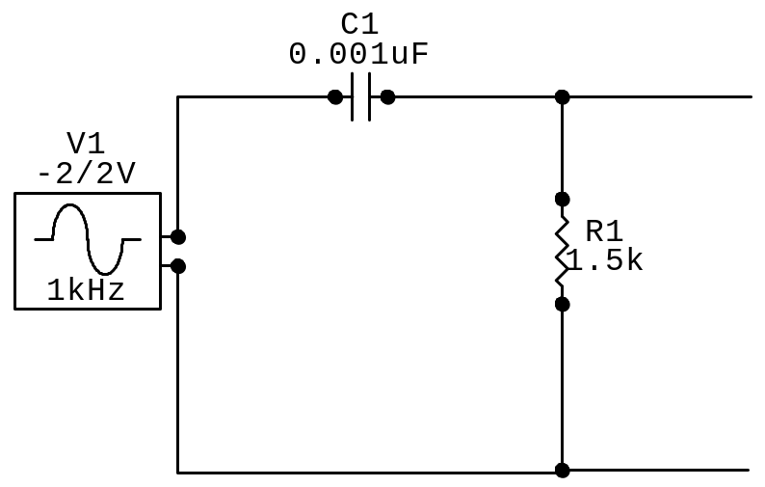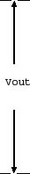

RC DIFFERENTIATOR

PROCEDURE

- Set up the circuit after testing all the components.
- Switch on the pulse generator and set the square wave input.
- Observe the input and output on two channels of the CRO.
- Note down the output waveform for the condition RC >> T.

OBSERVATION

Frequency | Vin(V) | Vo(V) | 20log(Vo/Vi) | log f
500Hz | 5 | .012 | -52.395 | 2.6989
800Hz | 5 | .016 | -49.897 | 2.9030
1kHz | 5 | .024 | -46.375 | 3.0000
8 kHz | 5 | .165 | -29.629 | 3.6989
10 kHz | 5 | .2 | -27.958 | 4.0000
60 kHz | 5 | 1 | -13.979 | 4.6989
100 kHz | 5 | 1.4 | -11.057 | 5.0000
300 kHz | 5 | 1.8 | -8.874 | 5.3010
800 kHz | 5 | 2 | -7.959 | 5.8569
1 MHz | 5 | 2 | -7.959 | 6.0000

RESULT

The circuit of RC differentiator was setup according to the circuit diagram and output waveforms are plotted.

INFERENCE:

Common applications of differentiator circuits are to detect the leading and trailing edges of a rectangular pulse or to produce a rectangular output from a ramp input.

